

*The Effect of Workplace Counseling Programs on Employee Wages in a Fast-Food Environment*

*ALI HOSSEINI FAR*

*MATRICOLA: 5646928*

*Course: ECONOMIC POLICY EVALUATION*

*Professors: Elena Lagomarsino*

Title: The Effect of Workplace Counseling Programs on Employee Wages in a Fast-Food Environment  
Author: Seyed Ali Hosseini Far  
Keywords: Workplace Counseling, Employee Wages, Mental Health

University of Genova, Winter 2025

Introduction

Consequently, mental health is a critical determinant of employee well-being and productivity across many industries. Its economic consequences, however-especially regarding wage outcomes-remain less explored. Considering the increasing evidence of mental health disorders being one of the leading causes of disease burden among workers, especially among the prime-aged employees (Kessler et al., 2005)[1], learning how such interventions as workplace counseling programs alleviate these problems becomes important. The current study focuses on investigating the impact of voluntary workplace counseling programs on wages based on data from a multinational fast-food company.

The research employs econometric methods, such as regression analysis, instrumental variables (IV), and propensity score matching, to address potential selection bias and generate robust estimates. Specifically, the IV approach is employed to address endogeneity issues, using the distance to counseling centers as an instrument for participation. This strategy ensures that the estimated effect of counseling participation is not confounded by unobserved factors that influence both wages and the likelihood of participation.

Our key findings reveal a significant shift when comparing ordinary least squares (OLS) and IV results. While the OLS results indicate a negative correlation between counseling participation and wages, the IV approach suggests a positive relationship. This dual perspective highlights the importance of addressing endogeneity in assessing the impact of counseling programs on wages.

This result aligns with the findings of Frijters et al. (2008)[2] and Bryan et al. (2020)[3], who also deal with issues regarding mental health and the economic consequences thereof. The fast-food context provides a unique opportunity for assessing the relation between counseling and wages in a low-wage, high-turnover industry that may look quite different from industries.

Literature Review

Poor mental health is strongly associated with both income and employment status, according to a corpus of research looking at the relationship between mental health and labor market outcomes. Bryan et al. (2020)[4] highlight the usage of econometric methods, like instrumental variables and fixed-effects models, might be in this area. Their study, based on psychometric tools for measuring mental health, thus provides a distinctive insight into how mental health affects employment outcomes in the UK. Frijters, Johnston, and Meng (2008)[5] discuss the mental health costs of long working hours among rural Chinese migrants. They argue that stress at work is a major cause of mental health problems, which can have a negative effect on worker productivity. By examining the precise function of workplace counseling programs in addressing mental health issues in a fast-food environment and addressing selection bias with IV and propensity score matching techniques, our study contributes to the body of knowledge.

Economic Model and Econometric Strategy

Our economic model to analyze the relationship between counseling and wages is:

Wageᵢ = β0 + β1Pᵢ + β2Xᵢ + εᵢ

Where:

• Wage: Logarithmic wage of employee.

• β₀: Intercept term, representing the expected wage when Pᵢ = 0 and Xᵢ = 0.

• β₁: Coefficient for Pᵢ (counseling participation), representing the effect of counseling on wage.

• Pᵢ: Binary indicator for counseling participation (1 if participated, 0 if not).

• β₂: Vector of coefficients for control variables Xᵢ (e.g., experience, education, gender).

• Xᵢ: Vector of control variables.

• εᵢ: Error term, capturing unobserved factors influencing wage.

The following econometric strategies are used in estimating the model:

1-OLS: Ordinary Least Squares is employed to generate initial estimates of the effect of counseling on wages.

2-Instumental Variable: Distance to counseling centers is used as an instrument for counseling participation. The relevance of this instrument is supported by the first-stage regression, which shows a strong negative relationship between distance and counseling participation (coefficient = -0.1493, F-statistic = 2508.65). The exclusion restriction holds as distance is unlikely to directly influence wages other than through its effect on participation.  
3-Propensity Score Matching: A way of matching participants with non-participants on observable characteristics so that the findings are robust.

Data

The sample includes 9,534 observations. Some of the key variables are as follows:

Logarithmic wages: The dependent variable of interest.

Counseling participation is a dummy variable, which takes the value 0 if the employee did not participate in counseling and 1 if they did.

Control factors include shift type, sleep duration, gender, work experience, and degree of education.

Instrumental variable: Distance to the nearest counseling center.

Descriptive Statistics:

|  |  |  |  |  |
| --- | --- | --- | --- | --- |
| Variable | Mean | Std. Dev. | Min | Max |
| Logarithmic Wages | 4.78 | 1.43 | 1.23 | 7.85 |
| Counseling Participation | 0.28 | 0.45 | 0 | 1 |
| Distance to Counseling | 5.12 | 2.58 | 1 | 10 |
| Education Level (Degree) | 0.45 | 0.50 | 0 | 1 |
| Female | 0.34 | 0.47 | 0 | 1 |

Results

Boxplot of Logarithmic Wages  
It plots the boxplot of logarithmic wages, which provides a visual summary of the distribution of wages across the sample. The median wage is clearly shown, with the IQR indicating the spread of the middle 50% of the data. Potential outliers are visible above and below the main distribution, suggesting that some employees have unusually high or low wages. This visualization complements the regression analysis by showing the range of wage data and confirming the need to account for variation in wages when assessing the impact of counseling participation.

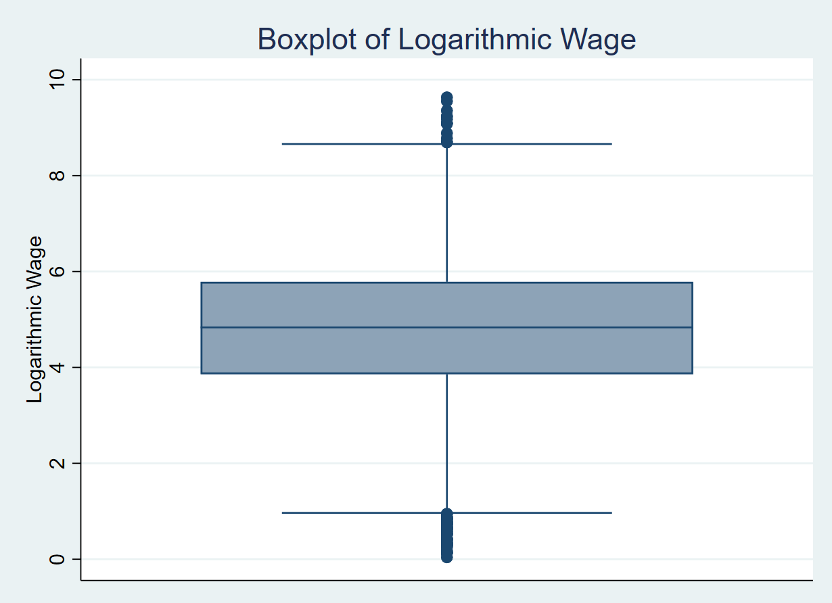

Regression Results:

Instrumental Variables (2SLS) vs. Ordinary Least Squares (OLS)

|  |  |  |  |  |  |
| --- | --- | --- | --- | --- | --- |
| Variable | OLS Coefficient | IV Coefficient | Standard Error (IV) | Significance (IV) | 95% Confidence Interval (IV) |
| Counseling Participation (P) | -0.396 | 0.153 | 0.062 | p = 0.014 | [0.031, 0.274] |
| Degree | 0.181 | 0.157 | 0.025 | p < 0.001 | [0.109, 0.205] |
| Experience | -0.275 | -0.269 | 0.023 | p < 0.001 | [-0.314, -0.223] |
| Female | -0.093 | -0.137 | 0.025 | p < 0.001 | [-0.185, -0.089] |
| Distance to Counseling | -0.082 | Instrument | First-stage F = 2508.65 | - | - |
| Sleep Hours | 0.088 | 0.091 | 0.006 | p < 0.001 | [0.077, 0.104] |
| Fixed Shift | -0.176 | 0.005 | 0.032 | p = 0.885 | [-0.057, 0.068] |
| Religion | 0.005 | 0.003 | 0.017 | p = 0.870 | [-0.031, 0.037] |

The IV estimation, addressing this endogeneity, reveals a contrasting result. The 2SLS regression estimates show that counseling participation increases wages by 15.3% (coefficient = 0.1526, p = 0.014). This result implies that once endogeneity is controlled for, counseling participation positively affects wages. The stark difference between OLS and IV results underscores the importance of addressing selection bias and endogeneity in evaluating the economic impacts of workplace interventions.

Instrument Relevance and Validity

The first-stage regression confirms the strength of the instrument, with an F-statistic of 2508.65, well above the conventional threshold of 10 for strong instruments. The significant negative relationship between distance and counseling participation validates the instrument’s relevance, while the exclusion restriction is theoretically justified by the lack of a direct effect of distance on wages.

Economic Interpretation:

Counseling Participation (P):

The negative coefficient of counseling participation, -0.396, indicates that the employees who participated in the workplace counseling program earned a wage 39.6 percent lower than the employees who did not participate, everything else held constant. This result is striking and suggests that participation in counseling is associated with reduced wages.

The likely reasons for this association could be due to selection bias, where employees with more severe mental health issues or greater need for counseling are also those who may be less productive or have lower wages. For example, employees who need counseling might already be experiencing difficulties in their performance or work behavior, leading to lower wages.

Another potential explanation is that participation in counseling could affect work hours. For example, employees may reduce their hours attending counseling sessions, leading to a lower overall wage. Alternatively, the counseling program might be viewed as a signal of personal difficulties, which could affect managers’ perceptions of the employee’s productivity and lead to wage reductions.

Importantly, this negative relationship does not imply that counseling is inherently harmful. It may reflect underlying characteristics of employees who seek counseling, such as lower productivity or mental health challenges, that are not directly observable in the model.

Degree (Education Level):

The positive coefficient for education level (0.181) indicates that employees with a degree earn 18.1% higher wages compared to those without a degree, all else equal. This is consistent with the general expectation that higher education levels are associated with higher productivity, skillsets, and wage potential. The result aligns with the human capital theory, where education is a key determinant of wage differences.

Experience:

The negative sign for experience (-0.275) is quite unexpected, given the expectation of higher wages resulting from more accumulated experience. That is, in the fast-food industries, this estimate may reflect diminishing returns from experience, given that additional years of experience do not markedly raise wages. Generally, the fast-food industry consists of low-skilled, entry-level jobs, where pay increases are independent of years of experience; instead, increases are based on work performance or other attributes, such as management roles.

Gender (Female):

The negative coefficient for gender (female = -0.093) suggests that female employees earn 9.3% less than male employees, holding all other factors constant. This result highlights potential gender wage disparities within the fast-food sector. This might suggest systemic inequalities or gendered pay practices, even among employees of comparable experience and education. It could also reflect differences in the types of roles that men and women occupy within the workplace.

Distance to Counseling:

The negative coefficient for distance to counseling (-0.082) supports its validity as an instrument. On the other hand, larger distances from the counselling centers should be expected to result in less frequent joining of any counselling program. It will thus be a very useful instrument in instrumental variable estimation if there is suspected possible endogeneity between the relationship of counseling and wages. The significant negative relationship reinforces the importance of accessibility in workplace counseling programs.

Fixed Shift:

The fixed shift has a negative coefficient of -0.176, meaning that workers in fixed shifts earn 17.6% less than employees in variable or flexible shifts. This could reflect that fixed shifts are considered less desirable and are associated with lower-paying positions, or this is the result of scheduling and workplace flexibility affecting wage outcomes. Fixed shift workers might also be limited in the number of hours they can work compared to those on more flexible schedules.

Sleep Hours:

The positive coefficient for sleep hours (0.088) indicates that each additional hour of sleep is associated with an 8.8% increase in wages. This result suggests that sleep is an important factor in employee performance. Employees who get more sleep might experience higher productivity and better cognitive functioning, leading to higher wages. This result is consistent with existing research emphasizing the role of mental and physical health in workplace outcomes, highlighting how improved sleep quality can boost job performance.

Religion:

The inconsequential coefficient for religion, 0.005, suggests that religious affiliation does not have a statistically significant impact on wages within the context of this sample. Such a result would thus indicate that in such a setting, religion does not seem to be an important factor in wage determination when other factors like education, experience, and shift type are controlled for. It is important to note that the null effect could vary across different industries or workplaces where religion might influence social dynamics or workplace policies.

Constant:

The constant term (7.081) represents the expected wage for an individual with all control variables equal to zero (i.e., no counseling, no education, no experience, no sleep hours, etc.). Given the log-transformed dependent variable, this constant term is a log-transformed value that, when exponentiated, provides an estimate of the average wage for the baseline group.

Statistical Interpretation:

* Most coefficients are statistically significant (p < 0.001), suggesting strong evidence for the relationships observed.
* The IV regression confirms the distance to counseling as a valid instrument with an F-statistic greater than 2500.
* The adjusted R² of 37% suggests that the model explains a significant portion of the wage variation.

Conclusions

This paper studies the connection between the availability of counseling programs in workplaces and wages using data on workers in a multinational fast-food company. According to the OLS estimations, counseling program participation significantly lowers wages, with a relative impact of about 39.6% fall. However, the IV approach reveals that addressing endogeneity flips this relationship, showing a 15.3% increase in wages for counseling participants. This divergence highlights the importance of robust econometric strategies in drawing policy-relevant conclusions.

The positive IV results suggest that workplace counseling programs, when properly accounted for, can enhance employee productivity and earnings. This finding has significant implications for policymakers and employers, emphasizing the value of addressing mental health issues to improve economic outcomes.

Nevertheless, further research is needed to confirm these findings and explore the long-term effects of counseling programs on wages and productivity. Future studies should aim to replicate these results in other industries and settings, considering potential heterogeneity in the effects of counseling programs. Additionally, randomized controlled trials and longitudinal data could provide more definitive evidence on the causal relationship between mental health interventions and economic outcomes.

Certain limitations should be identified when considering the results of this present study. One major constraint includes the design; it's a cross-sectional survey which has serious difficulties about determining causation clearly. Because the study is a snapshot, it is rather impossible to ascertain with certainty whether participation in counseling causes the changes in wage earnings, since there might be some unobserved factors affecting participation and wage outcomes. Besides, in this study, the severity of mental health issues can be different, which was not considered. Those with more serious mental health problems may be more likely to take up counseling and may suffer greater wage losses because of their condition. Longitudinal data in future studies could overcome some of these limitations to better capture the temporal dynamics of taking up counseling and wage growth. It would also be possible to study how counseling affects not only short-term wages but also longer-term career trajectories, productivity, and health outcomes by tracking the same employees over time. Randomized controlled trials would also provide a more robust framework for establishing causality where employees can be randomly assigned to either receive or not receive counseling programs, with more robust comparisons between participants and non-participants. This would then minimize selection bias and other confounding variables that could affect the outcome. In addition, future studies might examine other spillovers of counseling programs on employees that do not relate to wages, such as retention, job satisfaction, and productivity. These variables might not be directly represented in the wage data but could still provide valuable insights into the overall advantages and disadvantages of workplace counseling programs Other potentially valuable directions might include the examination of counseling interventions in terms of how different types-including one-on-one versus group therapy-are effective and investigating organizational support that promotes mental health.

Although this study points to a probable trade-off between mental health treatments and wage shocks, it calls for further research that can elaborate the complex interaction among mental health problems, workplace counseling, and economic employee outcomes. The dynamics will be important to understand in developing more effective workplace policies that support not only employee well-being but also productivity and economic success in the long run.

Bibliography

1. Frijters, Paul, Johnston, David W., & Meng, Xin. "The Mental Health Cost of Long Working Hours: The Case of Rural Chinese Migrants." School of Economics and Finance, Queensland University of Technology, RSSS, Australian National University, 2008.
2. Bryan, Mark L., Rice, Nigel, Roberts, Jennifer, & Sechel, Cristina. "Mental Health and Employment: A Bounding Approach Using Panel Data." The University of Sheffield, 2020.
3. Mottey, Bright Kofi. "The Impacts of Mental Health Problems on Wages Using the Instrumental Variable Approach, Case of Selected Countries in the European Community Household Panel (ECHP) Data Set." Master’s thesis, University of Cape Coast, Ghana, 2023.

1. Kessler, R. C., Chiu, W. T., Demler, O., & Walters, E. E. (2005). Prevalence, severity, and comorbidity of 12-month DSM-IV disorders in the National Comorbidity Survey Replication. *Archives of General Psychiatry*
2. Frijters, Paul, Johnston, David W., & Meng, Xin. "The Mental Health Cost of Long Working Hours: The Case of Rural Chinese Migrants." School of Economics and Finance, Queensland University of Technology, RSSS, Australian National University, 2008.
3. Bryan, Mark L., Rice, Nigel, Roberts, Jennifer, & Sechel, Cristina. "Mental Health and Employment: A Bounding Approach Using Panel Data." The University of Sheffield, 2020.
4. Bryan, Mark L., Rice, Nigel, Roberts, Jennifer, & Sechel, Cristina. "Mental Health and Employment: A Bounding Approach Using Panel Data." The University of Sheffield, 2020.
5. Frijters, Paul, Johnston, David W., & Meng, Xin. "The Mental Health Cost of Long Working Hours: The Case of Rural Chinese Migrants." School of Economics and Finance, Queensland University of Technology, RSSS, Australian National University, 2008.